Lesson 06 Demo 3
Setup Apache Server Using Ansible
Objective: To set up Apache web server using Ansible.

Pre-requisites: You need to have Ansible installed in order to proceed with this demo. If you don’t have it installed, refer to demo 1 of lesson 7.

Tools required: Ansible.
Steps to be performed:
1. Install Ansible on Ubuntu (You can skip this step in case Ansible is already installed)
2. Establish connectivity between Ansible controller and node machine
3. Write Ansible YAML script to install Apache server
4. Run Ansible YAML script

Step 1: Install Ansible on Ubuntu (You can skip this step in case Ansible is already installed)
1.1 Use the below commands on Ubuntu system to install ansible software.
sudo apt-get install -f
sudo apt-get install software-properties-common
sudo apt-add-repository ppa:ansible/ansible
sudo apt-get update
sudo apt-get install ansible
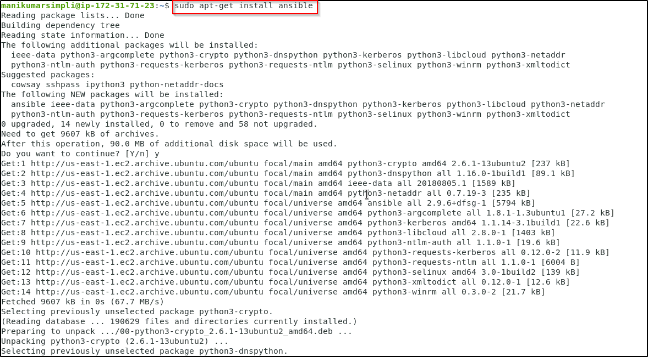
Step 2: Establish connectivity between ansible controller and node machine
2.1 Establish SSH key pair in linux system to have SSH connectivity with localhost using
the following command:
ssh-keygen -t rsa (Press Enter when asked for an input)
cat .ssh/id_rsa.pub >> .ssh/authorized_keys
ssh localhost -p 42006
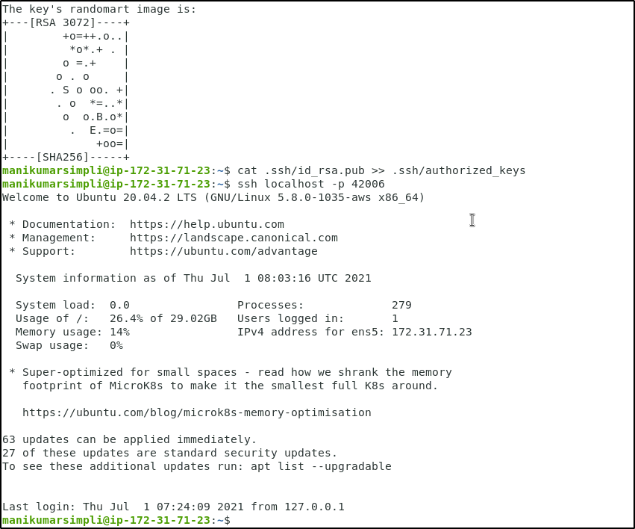

2.1 Now, add the host localhost in ansible host file /etc/ansible/hosts
sudo vi /etc/ansible/hosts
2.2 When the file opens, add the below two lines of the code at the end of the file if not added already:
[webservers]
localhost:42006
2.3 Execute the below command to validate the host inventory file
ansible -m ping webservers

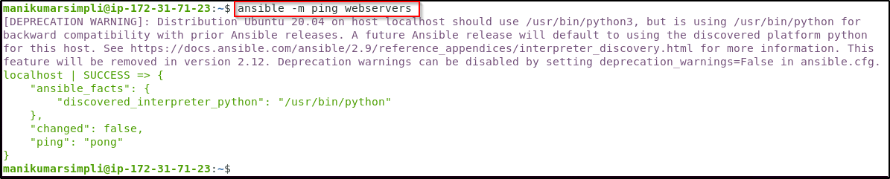

Step 3: Write Ansible YAML script to install Apache software
3.1 Once connectivity is established, add the following code in the apache.yaml file and
proceed with execution
3.2 Create and open the file using the below command
sudo vi apache2.yaml
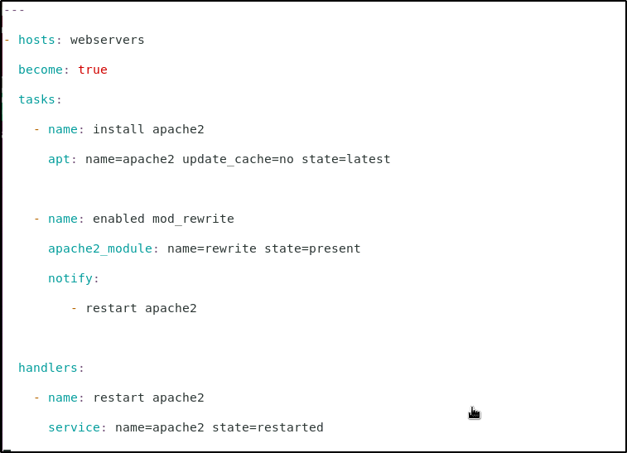
---
- hosts: webservers
become: true
tasks:
- name: install apache2
apt: name=apache2 update_cache=no state=latest

- name: enabled mod_rewrite
apache2_module: name=rewrite state=present
notify:
- restart apache2

handlers:
- name: restart apache2
service: name=apache2 state=restarted

Step 4: Run Ansible YAML script
4.1 Run apache.yaml file using the below command:

ansible-playbook apache2.yaml
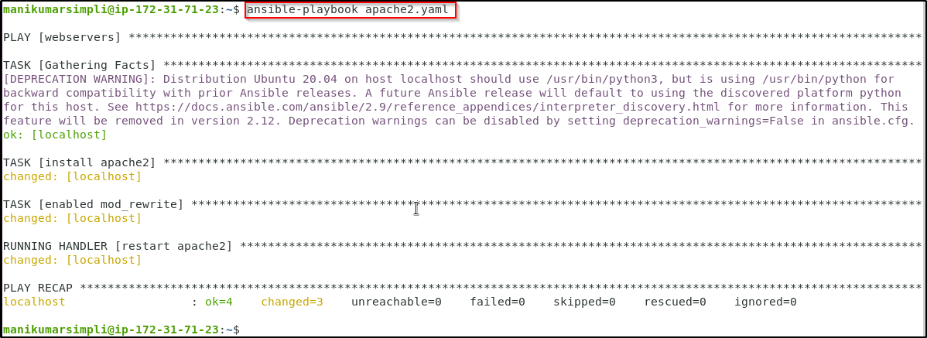

4.2 Validate the installation using the command:
ansible -m shell -a "service apache2 status" webservers
